📘 Lecture Notes Summary: B+ Trees and B Trees

1. Motivation
- Indexing (one or two levels) helps speed up queries, but large datasets need something more scalable.
- B-trees and B+ trees are used in databases and filesystems.
- They:
  - Maintain a balanced tree (all root-to-leaf paths are equal length).
  - Ensure efficient use of blocks (between 50% and 100% full).

2. Structure of a B-tree / B+ tree
- Order (n): Determines max keys per node.
  - Each node can hold up to n keys and n+1 pointers.
- Node Types:
  - Root – top level, at least 2 children (unless tree has only 1 node).
  - Intermediate/Interior nodes – contain keys + pointers to children.
  - Leaf nodes – contain keys and record pointers.

3. B+ Tree Rules

Leaf Nodes
- Contain copies of keys from the data file.
- Keys sorted left → right.
- Last pointer = next leaf (sequence pointer) → allows fast range queries.
- At least ⌊(n+1)/2⌋ pointers used.

Intermediate Nodes
- If j pointers are used, then there are j-1 keys:
  - Pointer 1 → records with key < K1
  - Pointer 2 → records with K1 ≤ key < K2
  - …
  - Pointer j → records with key ≥ Kj-1
- At least ⌈(n+1)/2⌉ pointers must be filled (except root).

Root Node
- At least 2 pointers (unless tree has only one record, then root = leaf).

4. B+ Tree Insertion
- Find leaf where new key belongs.
- If space → insert.
- If no space → split:
  - Leaf split:
    - Left node keeps ceil((n+1)/2) keys, right node gets rest.
    - Copy first key of right node up to parent.
  - Non-leaf split:
    - Middle key moves up to parent.
  - If root splits → new root is created.
- Splitting may propagate upward.

5. B+ Tree Deletion
- Find and delete the key from a leaf.
- If node occupancy < ⌊(n+1)/2⌋:
  - Borrow from sibling (prefer left).
  - Update parent if needed.
- If borrowing not possible → merge with sibling:
  - Adjust parent keys.
  - If parent underflows → repeat process upward.
- Root can shrink (if only one child remains).

6. Variants: B Trees
- B-tree differs from B+ tree:
  - Keys in non-leaf nodes have record pointers as well as child pointers.
  - So, non-leaf nodes: K keys + (K+1 child pointers) + K record pointers.
  - Leaf nodes not linked sequentially (no next-leaf pointer).
- Search stops at internal nodes (not always at leaves).

7. Key Differences Between B and B+ Trees
Feature | B Tree | B+ Tree
Records stored | Internal + leaf nodes | Only at leaf nodes
Search | May stop at internal node | Always goes to leaf
Range queries | Inefficient (must traverse) | Efficient (linked leaves)
Node pointers | K + (K+1) pointers | K+1 pointers

8. Exercises from Notes
- Calculate max/min keys for trees of given order and levels.
- Insert and delete keys into/from B+ trees & B trees.
- Compute number of records indexed given block size, key size, and pointer size.

✅ Key Takeaways
- B+ trees are most widely used in DBMS indexing.
- They ensure:
  - Balanced height (logarithmic search time).
  - Efficient block usage.
  - Fast range queries via linked leaf nodes.
- B trees are simpler but less efficient for range queries.

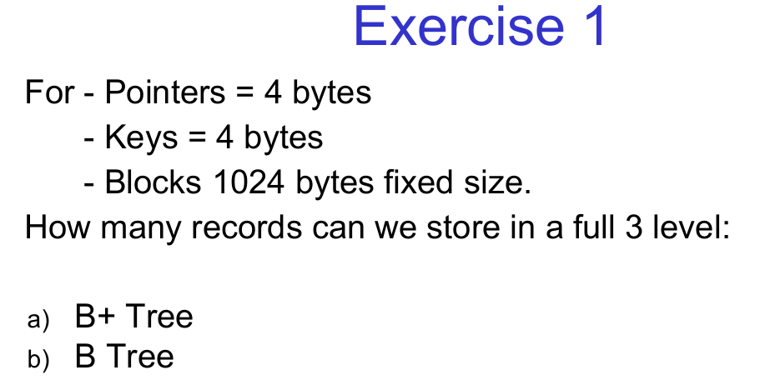

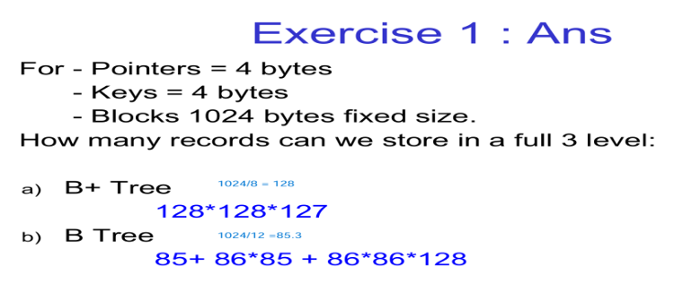

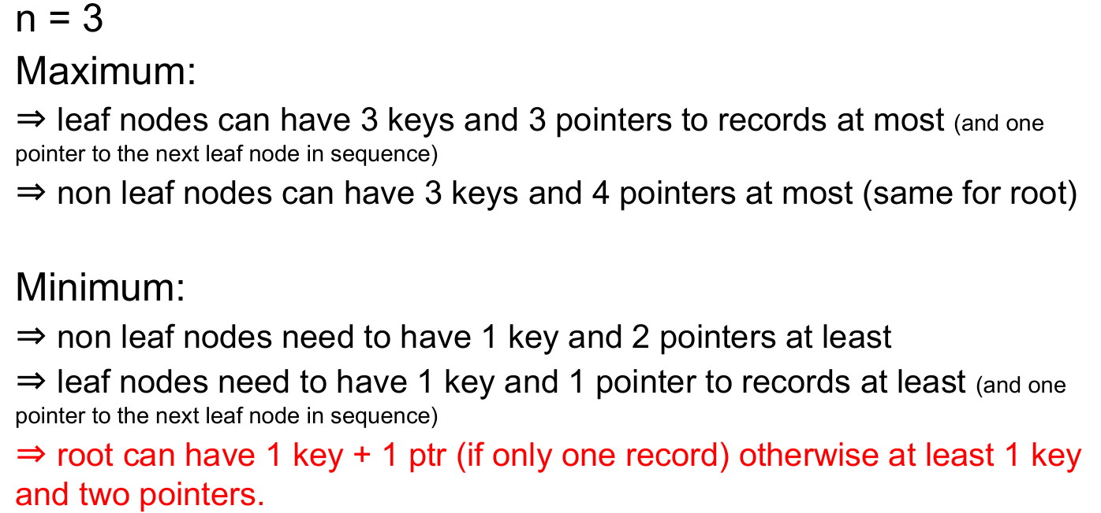

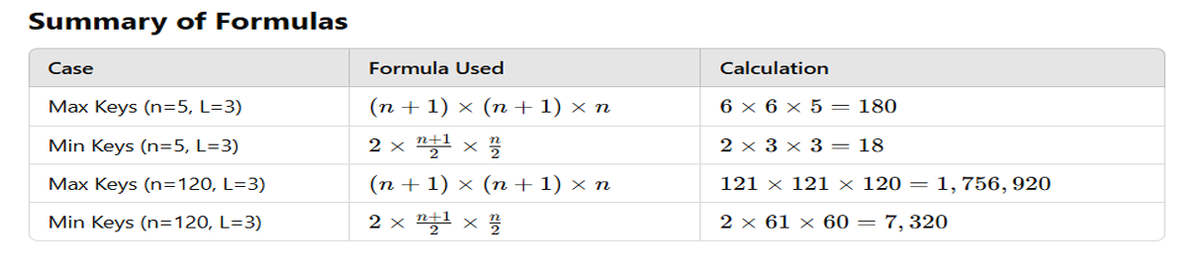

Exercise 2
For:
- Pointers = 8 bytes
- Keys = 4 bytes
- Block size = 512 bytes (fixed size)
How many records can be stored in a full 2-level:
a) B+ Tree
b) B Tree

Exercise 3
For:
- Pointers = 4 bytes
- Keys = 8 bytes
- Block size = 2048 bytes (fixed size)
How many records can be stored in a full 3-level:
a) B+ Tree
b) B Tree

Exercise 4
For:
- Pointers = 8 bytes
- Keys = 8 bytes
- Block size = 4096 bytes (fixed size)
How many records can be stored in a full 4-level:
a) B+ Tree
b) B Tree

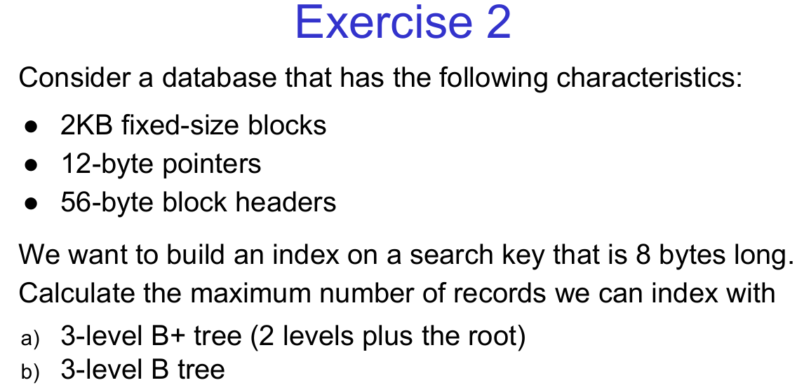
Exercise 2a) Consider a database with the following characteristics:
- 4KB fixed-size blocks
- 10-byte pointers
- 64-byte block headers
- Search key size = 12 bytes
Calculate the maximum number of records that can be indexed with:
a) 3-level B+ Tree (2 levels plus the root)
b) 3-level B Tree

Exercise 2b) A database system has:
- 8KB fixed-size blocks
- 16-byte pointers
- 128-byte block headers
- Search key size = 16 bytes
Determine the maximum number of records that can be indexed using:
a) 4-level B+ Tree (3 levels plus the root)
b) 4-level B Tree

Exercise 2c) Given the following database configuration:
- 1KB fixed-size blocks
- 6-byte pointers
- 32-byte block headers
- Search key size = 10 bytes
Find the maximum number of records that can be indexed with:
a) 2-level B+ Tree (1 level plus the root)
b) 2-level B Tree

Exercise 13.3.3 : Suppose pointers are 4 bytes long, and keys are 12 bytes long. How many keys and pointers will a block of 16,384 bytes have?

Exercise 13.3.3a: A database system has:
- Pointers = 8 bytes, Keys = 10 bytes, Block size = 8,192 bytes
How many keys and pointers will a block contain?

Exercise 13.3.3b: Consider the following database setup:
- Pointers = 6 bytes, Keys = 14 bytes, Block size = 32,768 bytes
Determine the number of keys and pointers that can fit within a single block.

Exercise 13.3.3c: Given a database structure where:
- Pointers = 16 bytes, Keys = 20 bytes, Block size = 4,096 bytes
Compute how many keys and pointers can be stored in one block.

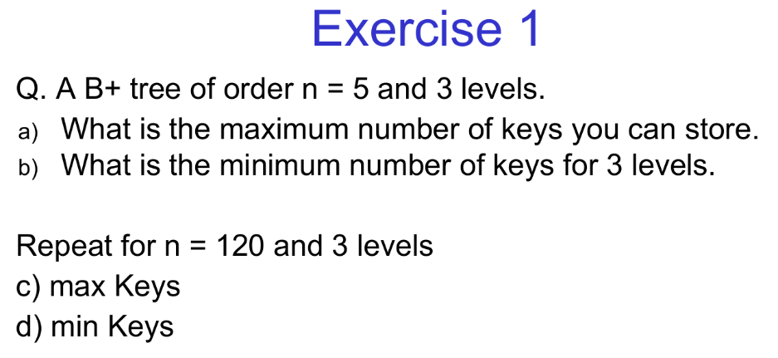

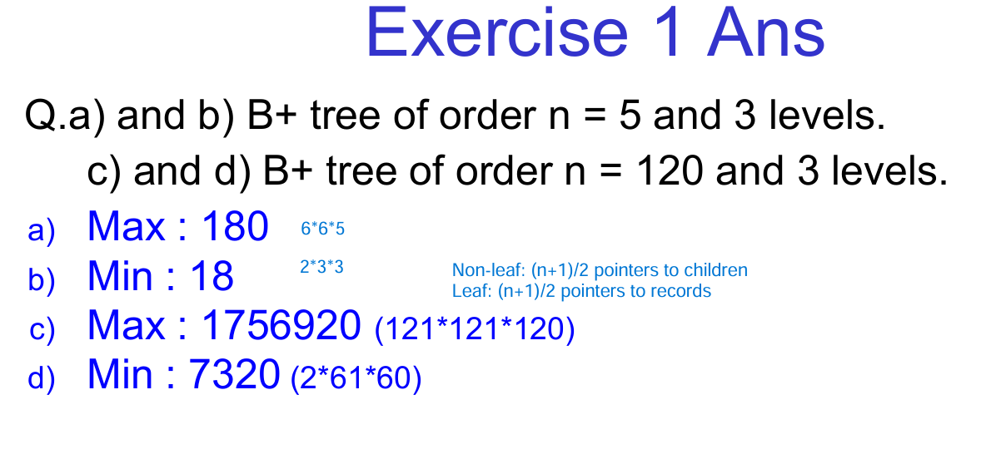
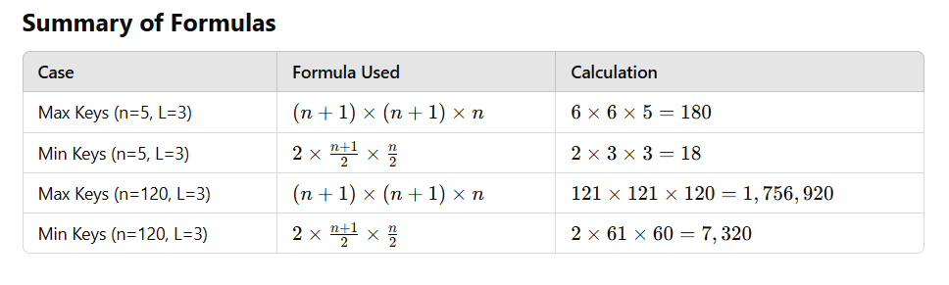
Exercise 1a
Q. A B+ tree of order n = 6 and 4 levels.
a) What is the maximum number of keys you can store?
b) What is the minimum number of keys for 4 levels?
Repeat for n = 100 and 4 levels:
c) Max Keys
d) Min Keys

Exercise 1b
Q. A B+ tree of order n = 8 and 5 levels.
a) Find the maximum number of keys that can be stored.
b) Find the minimum number of keys for 5 levels.
Repeat for n = 50 and 5 levels:
c) Max Keys
d) Min Keys
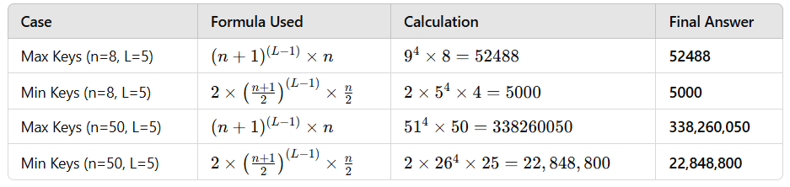

Exercise 1c
Q. A B+ tree of order n = 4 and 3 levels.
a) What is the maximum number of keys?
b) What is the minimum number of keys for 3 levels?
Repeat for n = 80 and 3 levels:
c) Max Keys
d) Min Keys

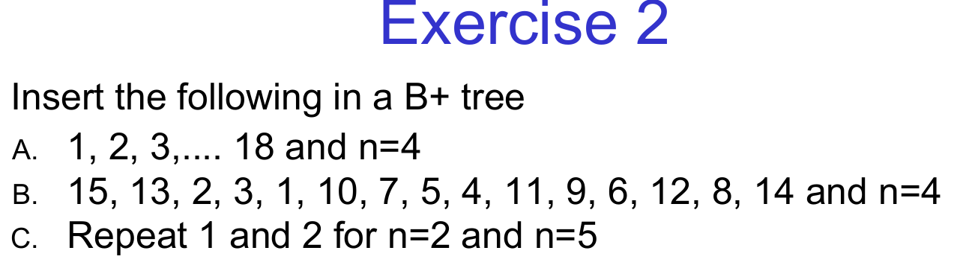
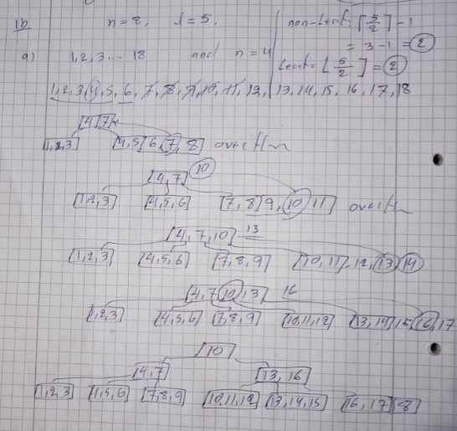

Exercise 13.3.9
If we use the 3-key, 4-pointer nodes how many different B+trees are there when the data file has the following
numbers of records: (a) 6 (b) 10 !! (c) 15.
Understanding the Problem
- We are using 3-key, 4-pointer nodes in a B+ tree.
  - This means each internal node can have up to 3 keys and 4 child pointers.
  - The leaf nodes store the actual records.
- The goal is to find the number of different possible B+ tree structures for given numbers of records.

Solution for Given Cases
We'll break down each case step by step.
Case (a): 6 Records
- A single leaf node can hold up to 3 keys.
- Since we have 6 records, we need 2 leaf nodes.
- The root node will have 1 key to separate these two leaf nodes.
- Possible variations:
  - The arrangement of keys in leaf nodes.
  - The choice of the separator key in the root.
🔹 Total possible B+ trees: Several possibilities exist, depending on key orderings. We'll count them carefully in a table if needed.

Case (b): 10 Records
- A single leaf node can hold up to 3 keys.
- Since we have 10 records, we need 4 leaf nodes (each containing 3, 3, 3, and 1 record).
- The internal structure will depend on how the records are split among internal nodes.
- The root will need multiple keys to manage these leaves.
🔹 Total possible B+ trees: A larger number of variations compared to (a), depending on ordering and key placements.

Case (c): 15 Records
- We need 5 full leaf nodes (3 records each).
- The internal node distribution will be more complex, possibly requiring multiple levels.
- The choices of separator keys significantly impact the number of valid B+ trees.
🔹 Total possible B+ trees: Much larger than (b), as the number of valid tree structures increases exponentially.

Three More Similar Questions
- Exercise 13.3.10:
A B+ tree uses 5-key, 6-pointer nodes. How many different B+ trees exist for:
  - (a) 8 records
  - (b) 12 records
  - (c) 20 records
- Exercise 13.3.11:
A B+ tree with 4-key, 5-pointer nodes. How many B+ tree structures are possible for:
  - (a) 10 records
  - (b) 16 records
  - (c) 25 records
- Exercise 13.3.12:
In a B+ tree using 6-key, 7-pointer nodes, how many different B+ trees exist for:
  - (a) 15 records
  - (b) 22 records
  - (c) 30 records
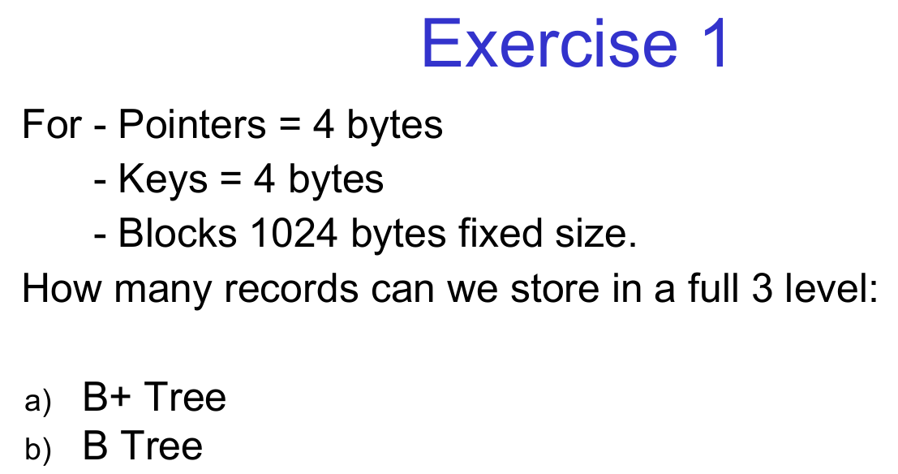
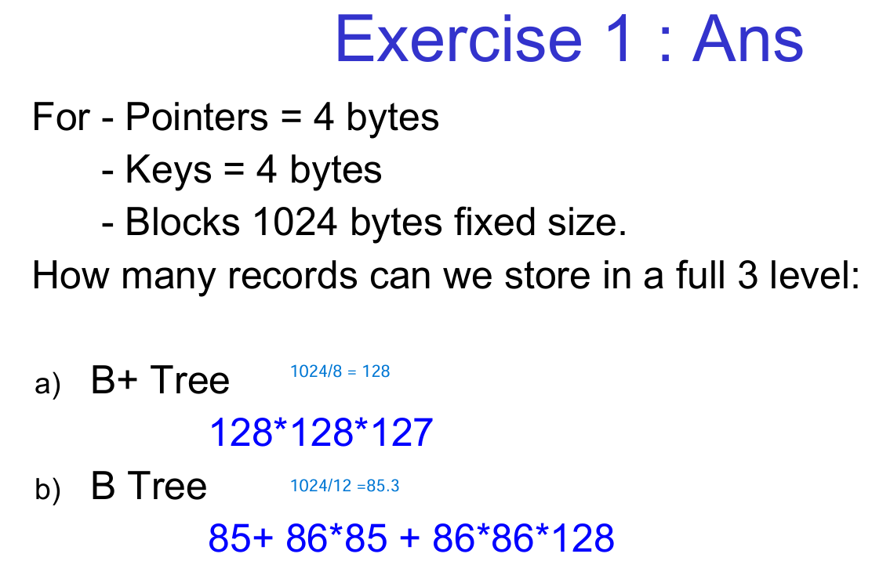
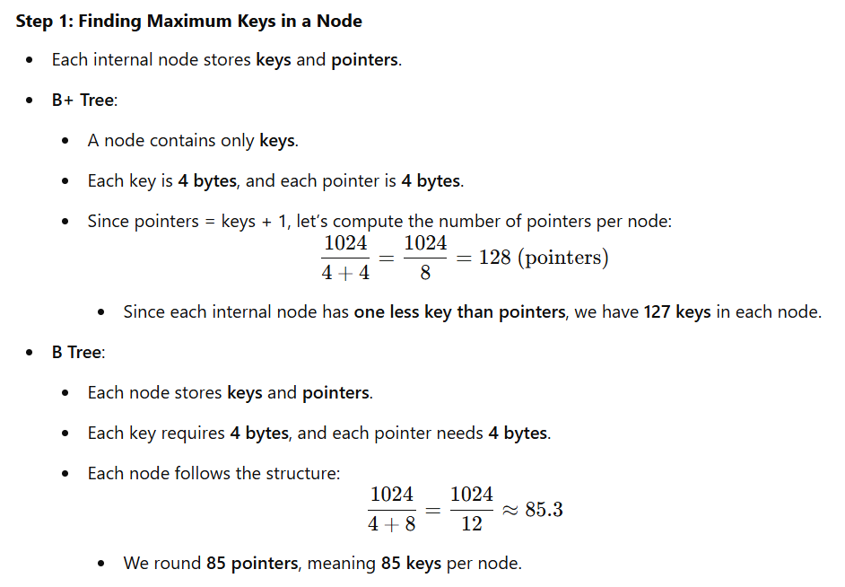
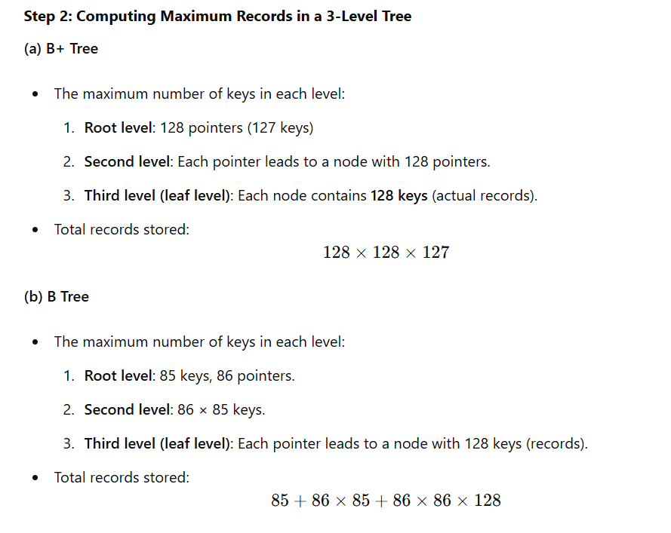
Three More Similar Questions
- Question 1:
Given a B+ Tree with 5-byte keys, 5-byte pointers, and block size 1024 bytes, how many records can be stored in a fully populated 3-level tree?
- Question 2:
A B Tree has 6-byte keys, 4-byte pointers, and block size 2048 bytes. Calculate the maximum number of records for a 4-level full tree.
- Question 3:
For a B+ Tree with 8-byte keys, 8-byte pointers, and block size 4096 bytes, compute the total number of records that can be stored in a 2-level tree.

Exercise 2
Consider a database that has the following characteristics:
● 2KB fixed-size blocks
● 12-byte pointers
● 56-byte block headers
We want to build an index on a search key that is 8 bytes long. Calculate the maximum number of records we can index with
a) 3-level B+ tree (2 levels plus the root) b) 3-level B tree

Three More Similar Questions
- Question 1:
A B+ Tree uses 4 KB blocks, 16-byte pointers, and 64-byte block headers.
The search key size is 12 bytes.
Compute the maximum number of records in a 4-level tree.
- Question 2:
A B Tree has 1 KB blocks, 10-byte pointers, and 40-byte block headers.
The search key size is 6 bytes.
Find the maximum records stored in a 3-level tree.
- Question 3:
Consider a B+ Tree with 8 KB blocks, 24-byte pointers, and 128-byte block headers.
The search key size is 16 bytes.
How many records can be indexed in a 2-level tree?

Three More Similar Questions
Question 1a:
Consider a database with the following characteristics:
- 4KB fixed-size blocks, 16-byte pointers, 64-byte block headers
We want to build an index on a search key that is 10 bytes long.
Calculate the maximum number of records we can index with:
a) A 3-level B+ tree (2 levels plus the root).
b) A 3-level B tree.
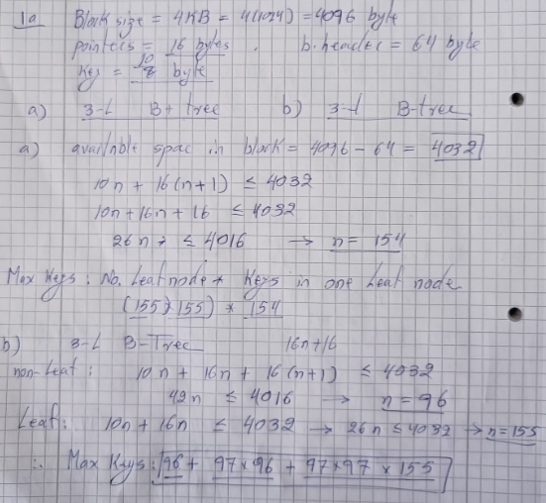

Question 1b:
A database system has the following characteristics:
- 1KB fixed-size blocks, 10-byte pointers, 40-byte block headers, The search key size is 6 bytes.
Find the maximum number of records that can be indexed using:
a) A 4-level B+ tree (3 levels plus the root).
b) A 4-level B tree.

Question 1c:
Consider a B+ Tree index in a database where:
- 8KB fixed-size blocks
- 24-byte pointers
- 128-byte block headers
The search key size is 12 bytes.
Determine the maximum number of records that can be stored using:
a) A 3-level B+ tree (2 levels plus the root).
b) A 3-level B tree.

